Bratislava Airport is taking responsibility for customer service at every stage of the airport journey. We offer private aircraft handling services as well as passenger and crew transportation, catering and hotel accommodations etc. General aviation clients have separate terminal at their disposal, which offers privacy, quick handling process and services of the highest standard. Our team is available 24/7 throughout the year to meet your requirements.
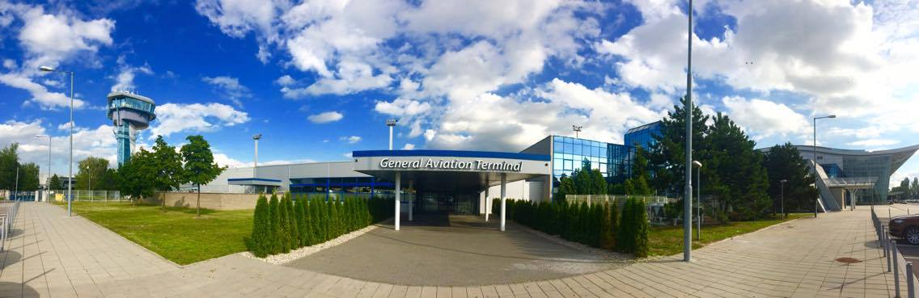

Contact details

General Aviation & VIP Services, Letisko M. R. Štefánika – Airport Bratislava, a. s. (BTS),
P. O. Box 160, 823 11 Bratislava 216, Slovak Republic

GPS coordinates:
N 48.1702076
E 17.1991187

TLF/FAX: +421 2 3303 3354 / +421 2 4329 1573
MOBILE: +421 903 205 189
SITA: BTSKX7X

E-MAIL: generalaviation@bts.aero
WEBSITE: www.bts.aero

RADIO /ops/: 131,85 MHz

TRAFFIC HOURS: 24/7 (including immigration and customs)

General information

- Slot regulation
Bratislava Airport is designated as IATA Level 2 Schedules Facilitated Airport in accordance with Council Regulation (EEC) No 95/93 and international standards set by IATA.

GA/BA slots only
E-MAIL): ga.slots@bts.aero
TEL: +421 2 3303 3312
WEBSITE: https://www.bts.aero/en/b2b/slot-coordination/general-aviation-and-business-aviation/

Commercial Ops
E-MAIL: slots@bts.aero
SITA: BTSSC7X
TEL: +421 2 3303 3360
WEBSITE: https://www.bts.aero/en/b2b/slot-coordination/

- Landing Clearance
Regulations concerning entry, transit and departure of non-scheduled flights of foreign civil aircraft are stated in AIP Slovak Republic /GEN 1.2.1.3.1.1. and 1.2.1.3.1.3/.
The application should be submitted to:

Postal address: Ministry of Transport, Construction and Regional Development of the Slovak Republic
Directorate General of Civil Aviation and Water Transport, Directorate of Civil Aviation
Námestie slobody 6
P. O. Box 100
810 05 BRATISLAVA 15
Slovak Republic

TEL: +421 2 52 73 14 57
FAX: +421 2 52 73 14 70
AFTN: LZIBYAYX
e-mail: trafficrights@mindop.sk

- Fire category
Bratislava Airport is classified in fire category 7, or category 8 (2 hours request in advance needed). Category 9 is available for cargo/mail flights only.
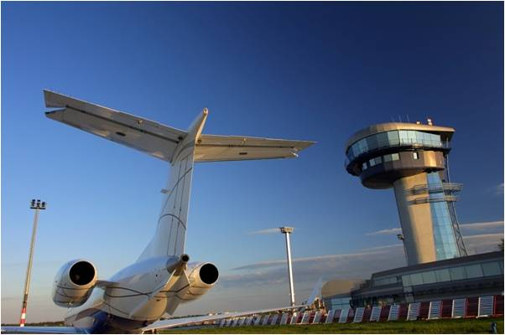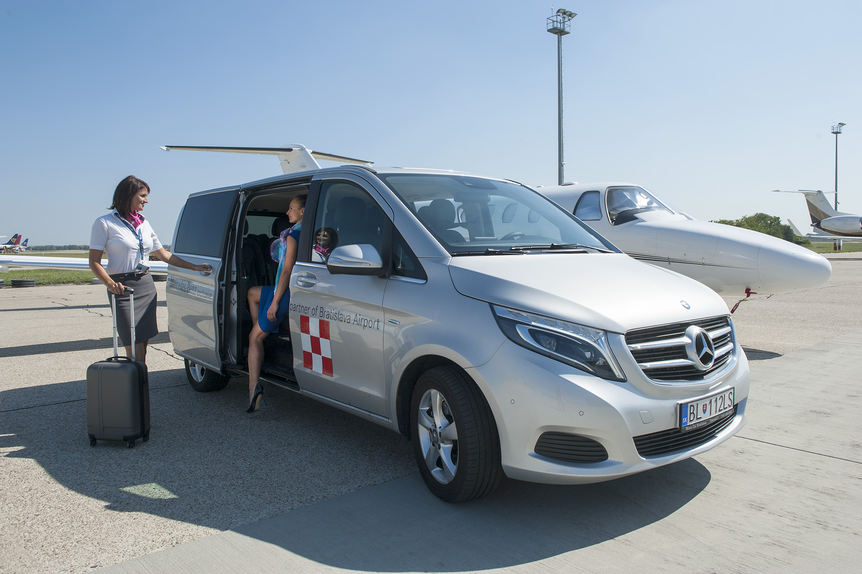

Airport Charges
- Landing Charge: 13,11 EUR / per t MTOM
Charges for aircraft landing with more than 150t MTOW are calculated in accordance with AIP of the Slovak Republic, part 4.1.1.2.b.
Charges for training landings are calculated in accordance with AIP of the Slovak Republic, part 4.1.1.3.2.

- Parking Charge: 0,30 EUR / per t MTOM and per hour
Charges for aircraft parking with more than 100t MTOW are calculated in accordance with AIP of the Slovak Republic, part 4.1.2.2.2.

- Passenger Charge: 16,27 EUR / per departing passenger
Flights with State / Head Status marked in flight plan are free of above mentioned charges.

Charges are without 20% VAT.

Handling Charges
We will gladly provide you with our handling charges on request.

Payment conditions
You can avail payment:
- In cash /EUR, USD/ - up to 5000 EUR,
- By CC / EC/MC, Visa, DCI, Amex/,

Other fees
Approach fee is charged by the company Letove Prevadzkove Sluzby Slovenska Republika /ATC/:

TLF: +421 2 4857 2280-1
FAX: +421 2 4342 3390
AFTN: LZIBZPZX
E-MAIL: briefing@lps.sk

Refuelling
There are two companies providing fuel uplift at Bratislava Airport:

Slovnaft, a. s.
Fuel type: JET A1, AVGAS 100LL
Working hours: H24
Business hours: 0630z-1430z, MON-FRI
TLF: +421 2 3303 5650-1
FAX: +421 2 3303 5652
MOBILE: +421 903 455 253
E-MAIL: jana.badova@slovnaft.sk
Payment conditions for fuel are:
- In cash,
- By CC /Ec-Mc, Visa, DCI, Amex/,
- Fuel carnets /only JET A1/ World fuel services, Colt International, Multiservice/AVCARD

SHELL Slovakia, spol. s r. o.
Fuel type: JET A1
Working hours: H24
Form of payment: Shell carnet

- For fuelling request please forward it to: Aviation-EUSA@shell.com
- Out of hours helpline (24 hours) : +44 207 026 3268
- In case of any urgent cases or requests for quotations please contact Sales Support Teams:
SDO-Aviation-Sales-Support-CEE@shell.com

In accordance with the Law of Consumer Tax only Air Operators who has been found to conduct Commercial Air Transport Operations are free of consumer tax for fuel. We would like to provide you the best conditions and not add the consumer tax into your invoice if not necessary. Under these circumstances, in your own interest, please send us your Air Operator Certificate.
Catering service
We are pleased to offer you catering services of the highest quality. Our staff has a wealth of experience with catering arrangements for all type of flights, i. e. business, VIP, state flights. Please contact us and discuss your catering requirements. Please note, that the catering can be ordered and delivered from companies certified in Slovakia only.

General Aviation Terminal

GAT will ensure your clients comfort and privacy.
General Aviation terminal offers reception services H24, wide choice of alcoholic and non-alcoholic beverages and snacks, private car parking and the service of our professional staff. The terminal operates its own passport, customs and security control as well as equipment for oversized luggage screening. A free Wi-Fi connection is available throughout the terminal.
The Full VIP Service in the public zone of the VIP terminal is charged 49 € per person (VAT excluded). “Go through” is free of charge.
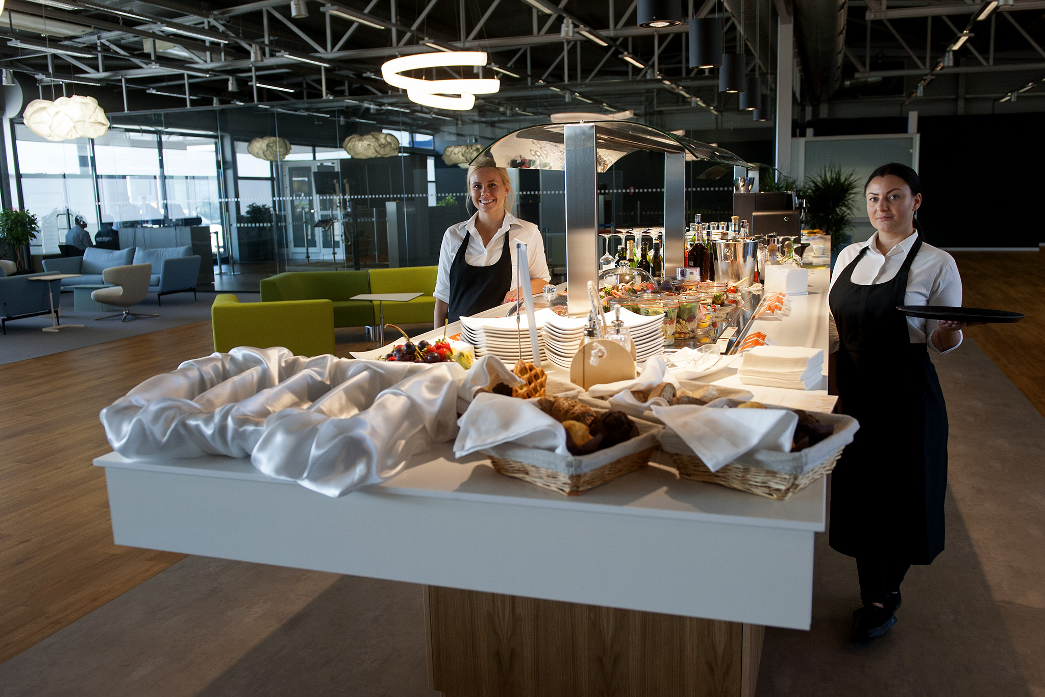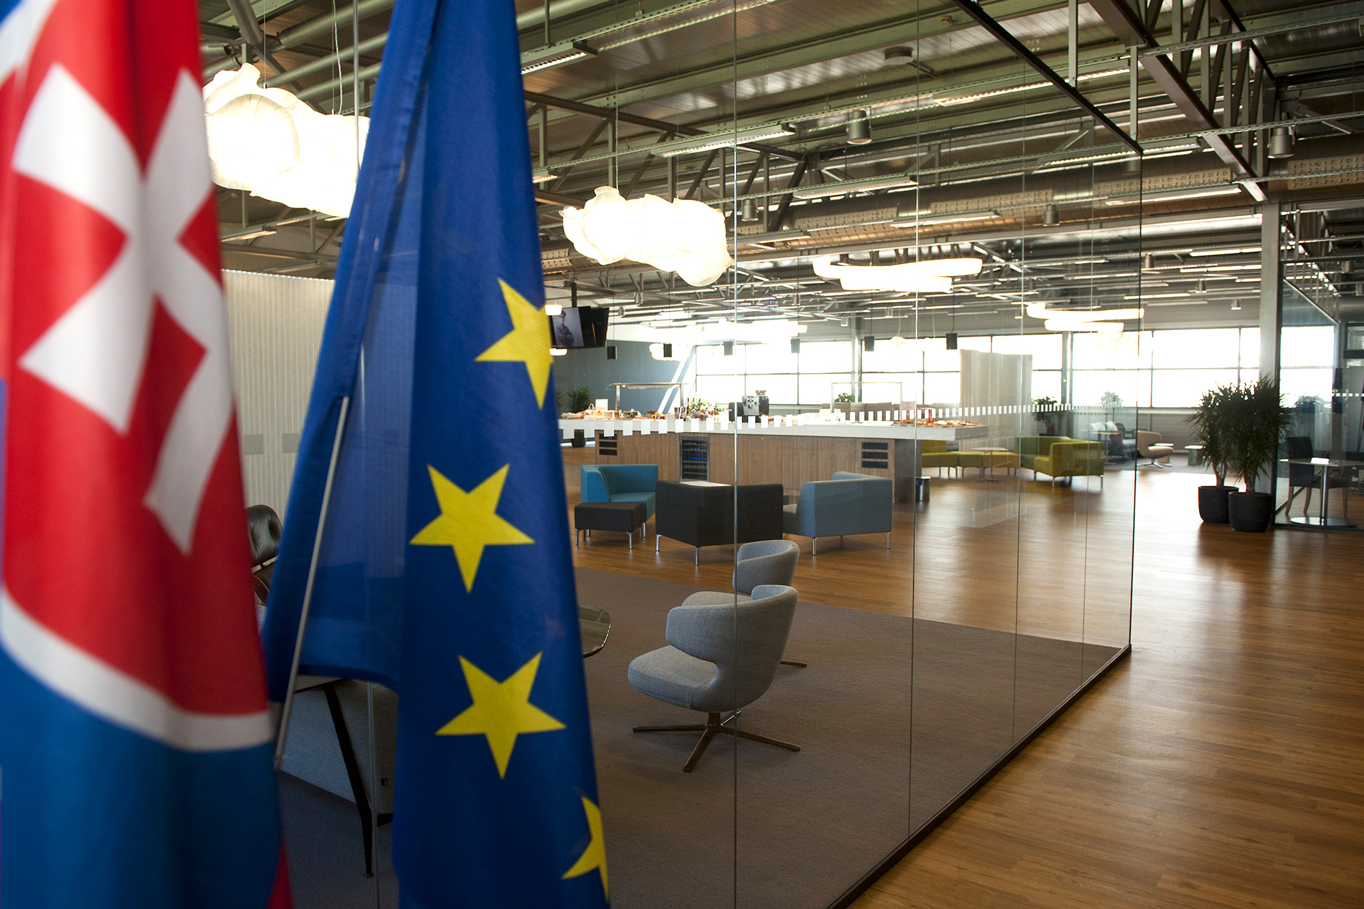
Hotel arrangements

Hotel rates are greatly fluctuating during the year; therefore we have arranged fixed rates during high seasons and guarantee you the lowest price. We shall gladly arrange hotel reservation on your behalf downtown or in the vicinity of the airport. We are happy to include costs from our contracted hotels in your handling invoice.

Our contracted hotels:

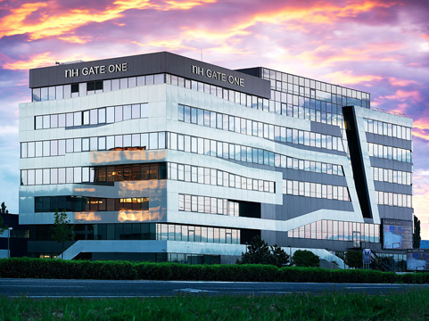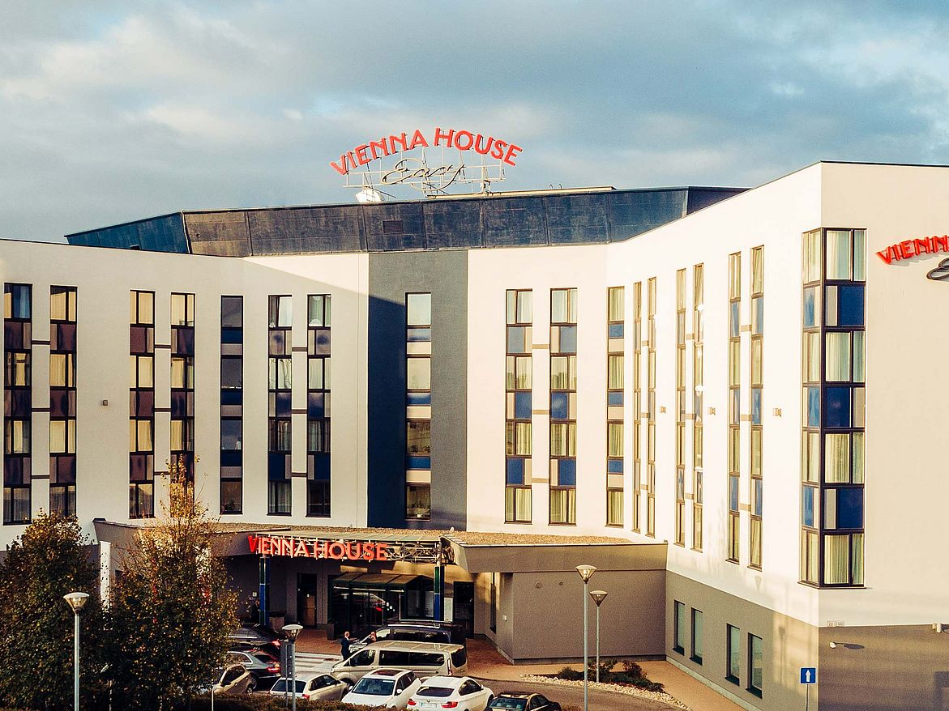
NH Gate One **** Location: Airport Vienna House Easy *** Location: Airport
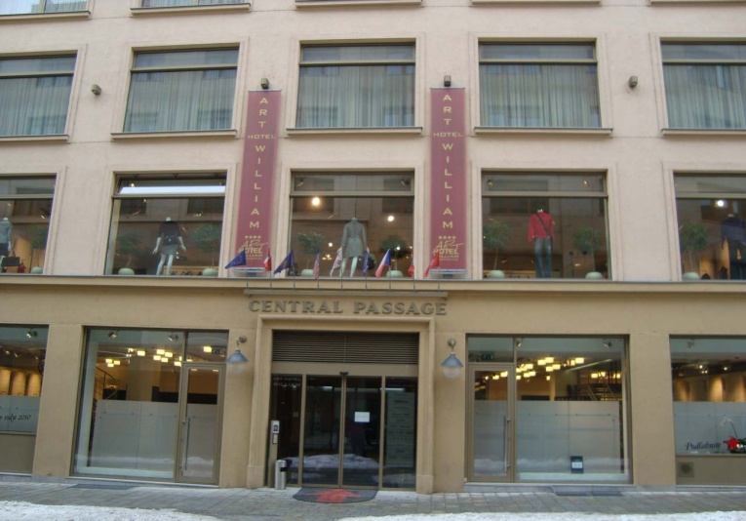
Art Hotel William**** Location: Downtown Double Tree **** Location: Airport/Downtown

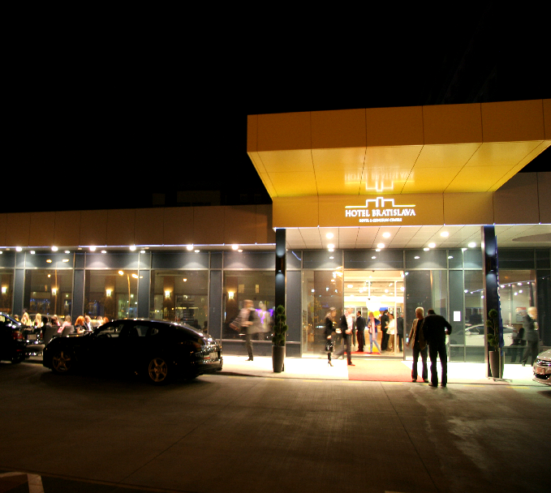
Crowne Plaza **** Location: Downtown City Hotel Bratislava **** Location: Downtown

Transportation service

We shall gladly arrange any transportation and limousine service in accordance with your needs. Our experienced partners with English speaking drivers will bring you and your guests safely to your destination and pick you up at the prearranged time. We are happy to include these costs in your handling invoice.
